**Installing Jfrog using Docker and creating the package of Application and store in Artifactory**

1. To install jfrog use the command below :

docker pull docker.bintray.io/jfrog/artifactory-oss:latest

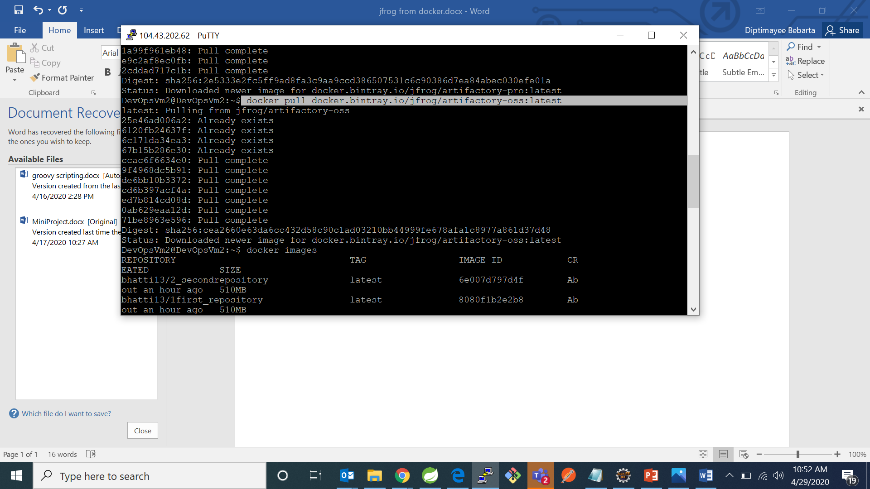

1. To check all images in the vm use the below command :

docker images

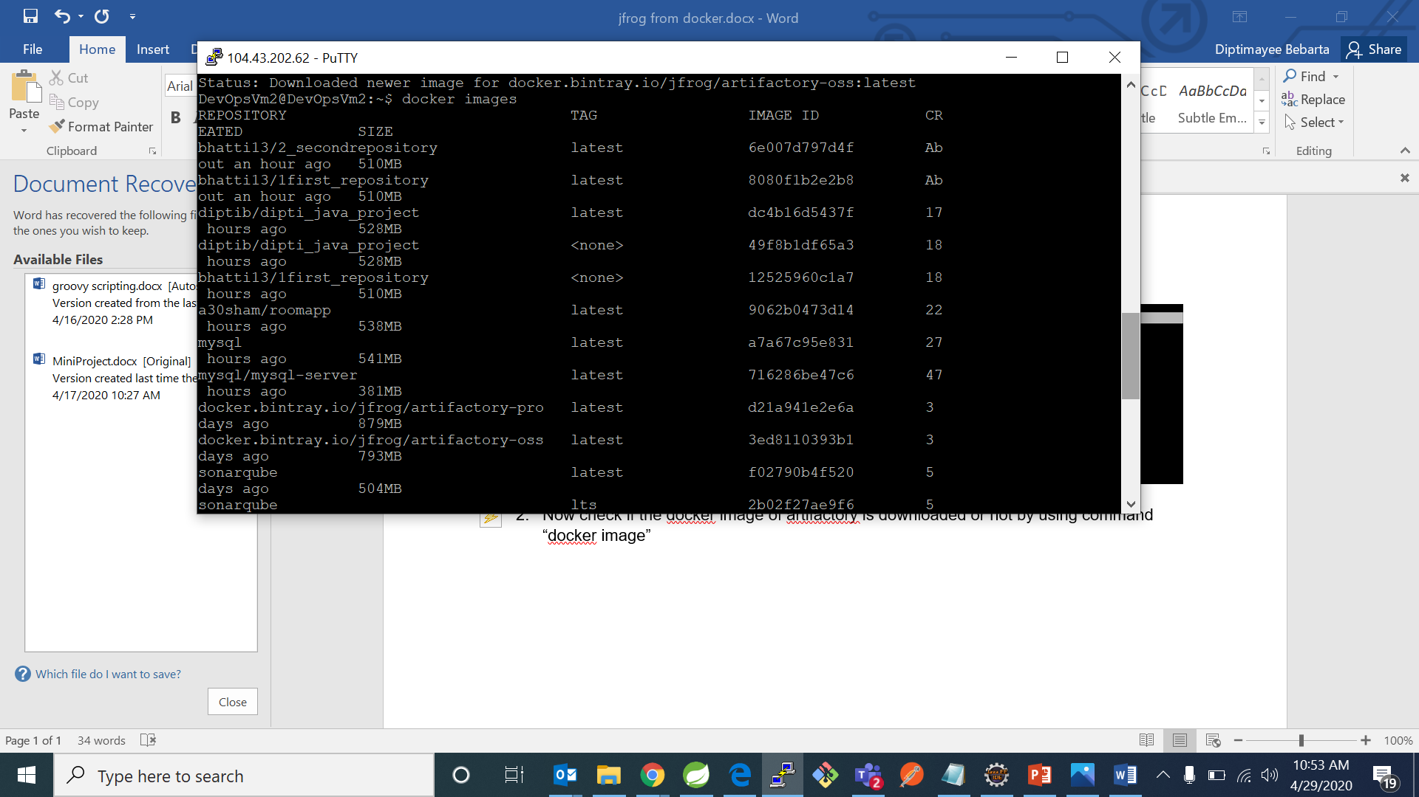

1. To run the jfrog on port 8082 we will be using command as given below :

docker run --name artifactory -d -p 8082:8082 docker.bintray. io/jfrog/artifactory-oss:latest

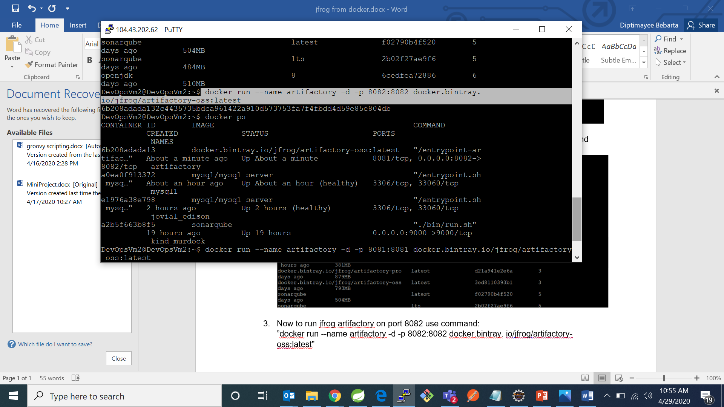

1. To display all the containers in the docker we will be using the following command :

docker ps

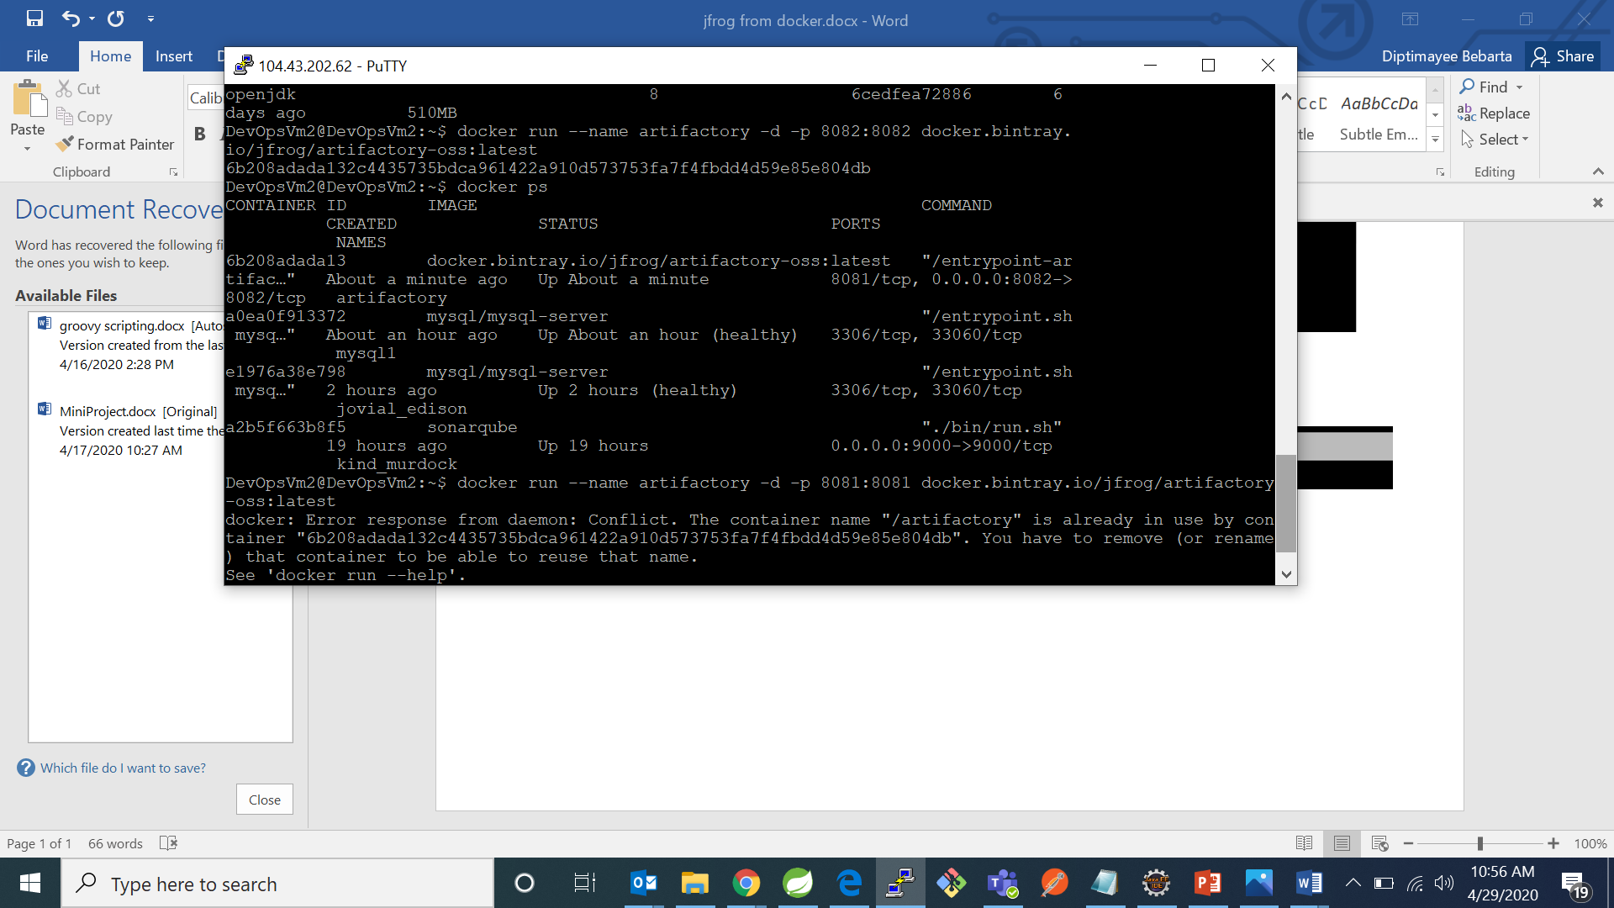

1. After Running jfrog image on docker use the url <http://server:8082/artifactory> and register to jfrog

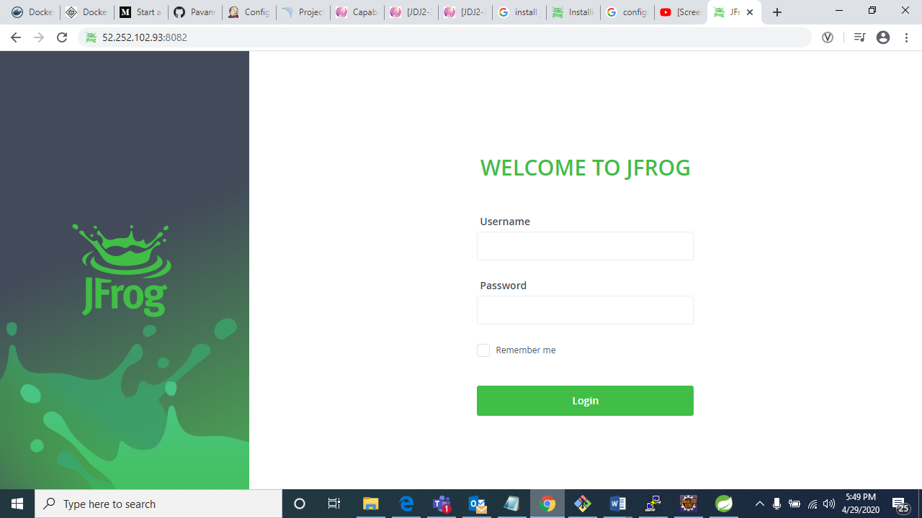

**Creating the Package of application and storing it in the Artifactory :**

Step 1: Create a new

project in Jenkins, clone your project of your git by mentioning the repository url of your project in source code management and give the credentials as shown in the image below :

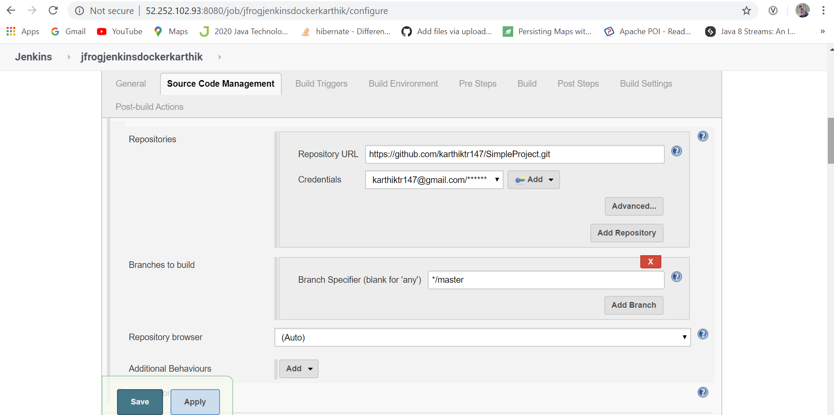

Step 2: In the Build Environment tick Enable Artifactory release management as shown in the image below.

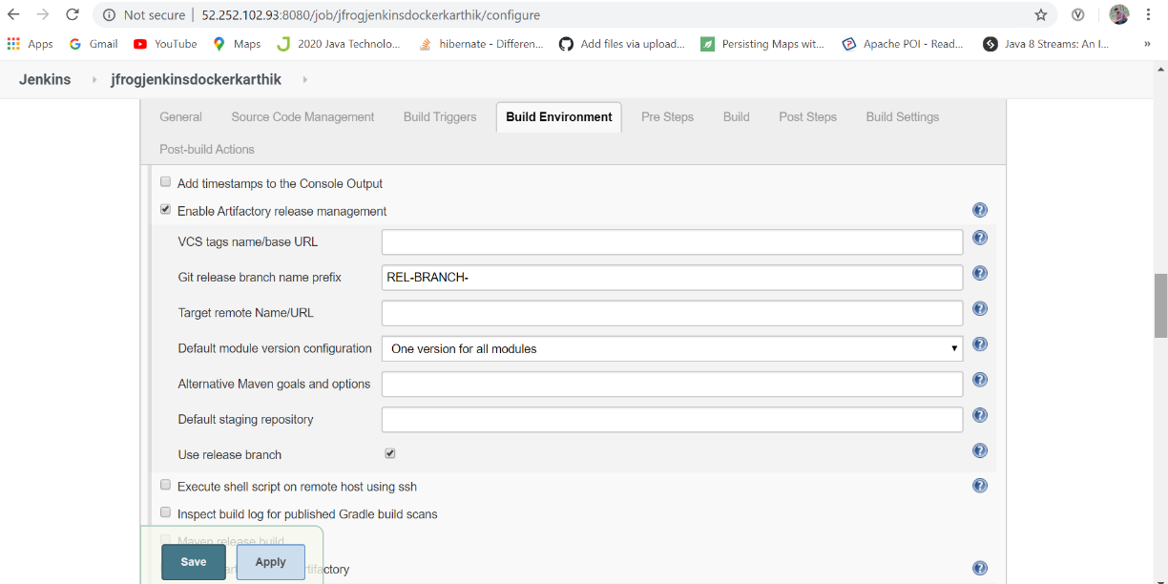

Step 3: In the Build environment tick Resolve artifacts from Artifactory and click on refresh Repositories and from the dropdown in Resolution snapshots repository select libs-snapshot.

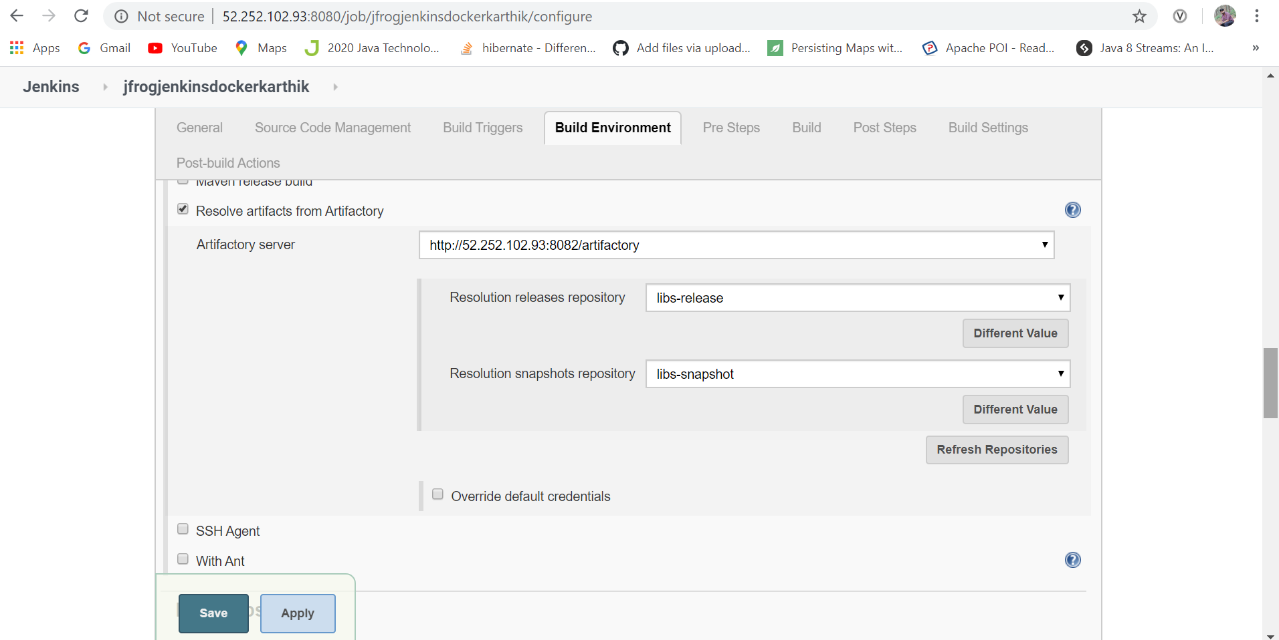

Step 4 : In Build mention I have mentioned clean install.

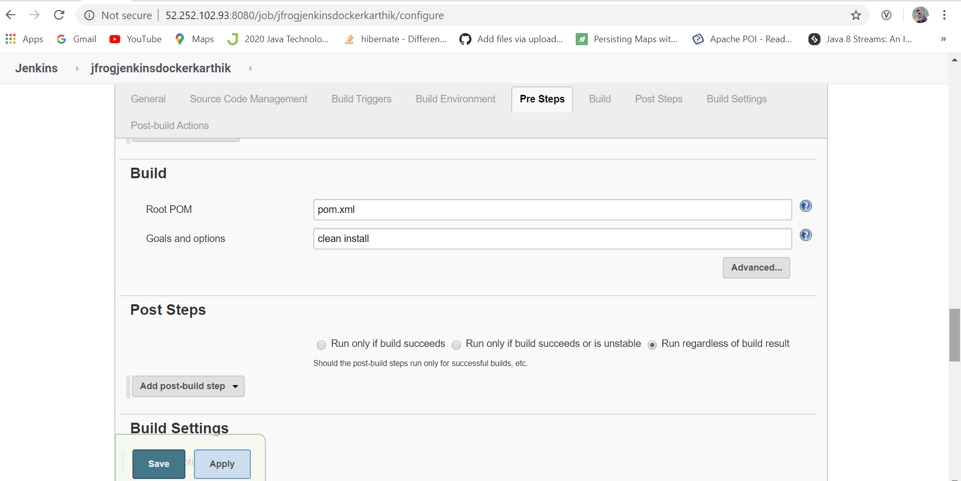

Step 5: In post build actions tick select Deploy artifacts to Artifactory and click on refresh Repositories and from the dropdown in Target snapshots repository select libs-snapshot.

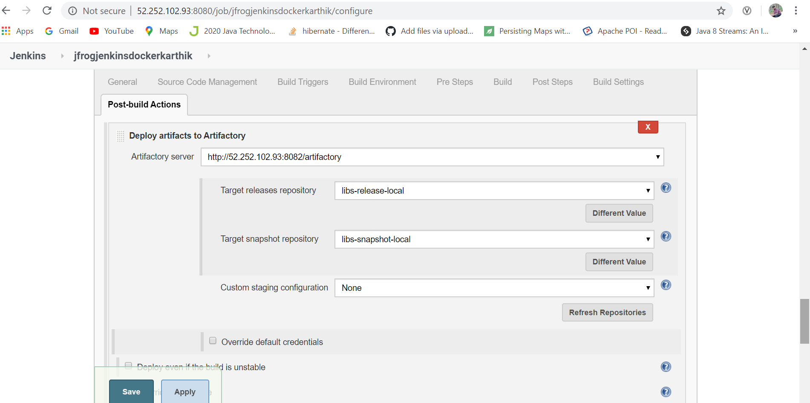

Step 6: After Following above click on save and apply and click on build now after that below is the console output of the build results.

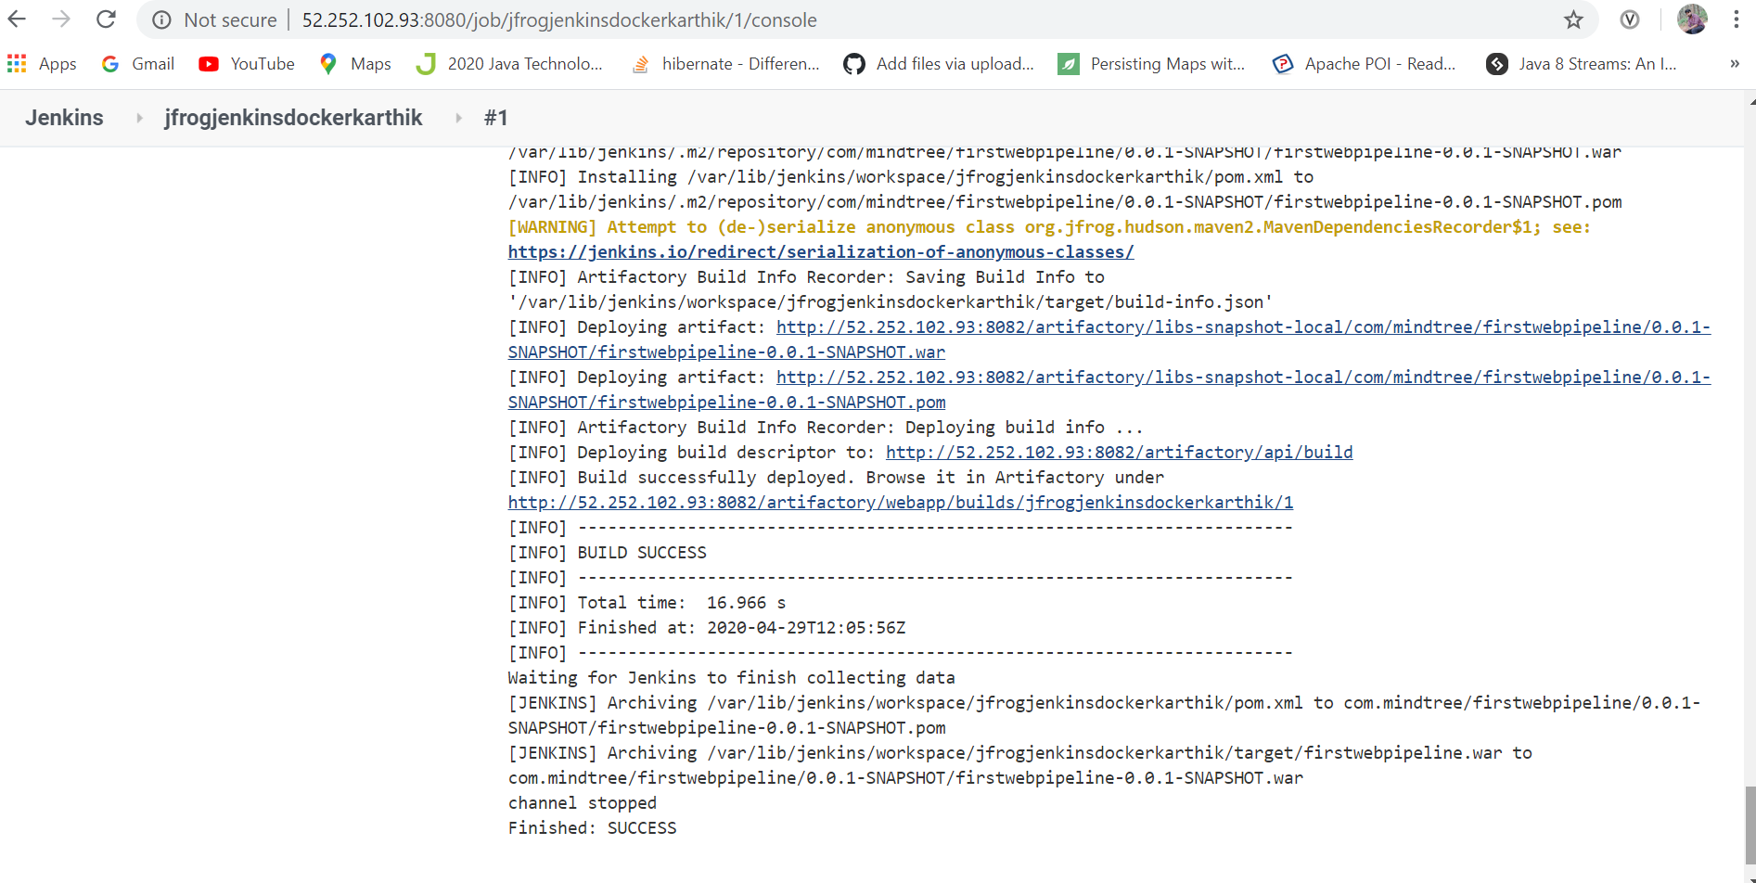

Below is the image of the artifacts added to jfrog artifactory .

